Hearts Open Here
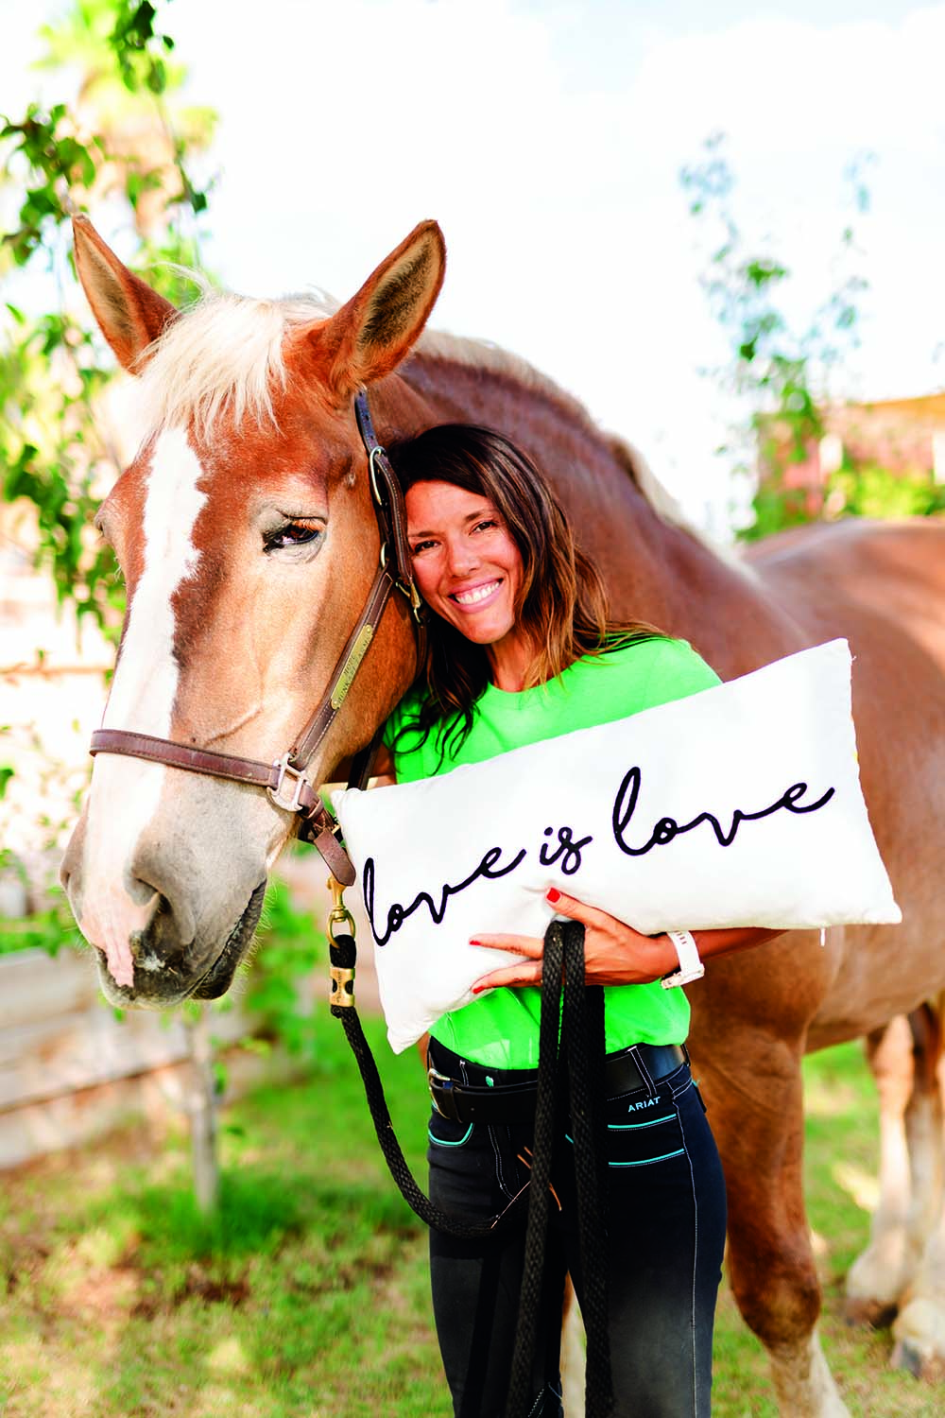
Terra with ‘Hope’
The word “I am related to everyone.”
hun•ka•pi /hun-kah-pee/ - A Lakota word

With February being Valentines — the month of love, I could not think of a better way to recognize all the many facets the miracle of love is, than with this interview with Terra Schaad, CEO and founder of Hunkapi Farms.
You might not think one of the most inspirational and healing places is right here in Scottsdale, AZ. I think we’re known more for our golf courses, shopping, dining and hiking. Yet Hunkapi Farms is centered within minutes from the hustle and bustle of daily life, and the sounds of traffic noise.

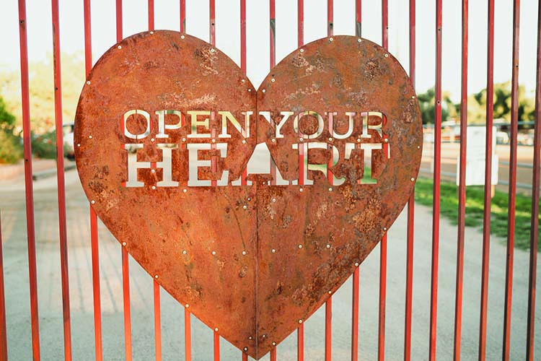

Once the gates of the farm open — you know you’ve arrived somewhere extremely special….a place you don’t want to leave.
I’ve known Terra and the Hunkapi team for years, and have witnessed their expansion, from the number of clients they serve each week to the growing number of rescue animals who now call the land they run and gallop around on, home. It’s a beautiful menagerie of people and animals. Every time I’m there, I fill up with harmony, healing and hope.
— Barbara Nicholson-Brown

What was the initial inspiration for creating Hunkapi Farms, and its history.
Hunkapi was initially founded in 1999 at Arizona State University after three years of extensive research. It found its way to Scottsdale in 2008, and we have proudly claimed to be a part of the Wests Most Western Town ever since. Hunkapi was created to give horses to children with special needs.
Today, Hunkapi Farms continues to work with children who have special needs, and we have also extended our services to include children and adults with diagnoses that include post-traumatic stress, ALS, cancer, addiction disorders, autism, and more. Hunkapi is the home to 32 therapy horses, and two rescue cows. We also have goats, turkeys, and pigs scampering about the land.
We serve between 250 and 300 clients per week. Hunkapi also is homebase to 50-100 volunteers who help out with various tasks and needs.

At Hunkapi you teach the ‘World to Fear Less and Love More’. This is a beautiful philosophy for living. How do your clients respond to this message?
At Hunkapi we want people to know to live a life without fear is unrealistic. It is a practice, however, to feel our fears, acknowledge them, and then find ways to nurture and nudge ourselves through them. Once people learn not to hide from their fears, but get more curious about them, it’s empowering and exciting to watch. There is so much we can change, with far less shame and guilt, when we practice using curiosity rather than flight from our fears.

Tell us about the programs you provide for addiction recovery and first responders.
Hunkapi offers on going equine assisted psychotherapy groups for addiction recovery programs in the Valley, and we proudly partner with several recovery programs in the valley. We also offer gratis, six-week, stress reduction groups for first responders. Individuals who are interested in continuing with private, equine therapy programs following their group sessions or in lieu of them are also able to work privately with one of our licensed counselors.

What are a few of the inspiring moments working with clients who have struggled with trauma/PTSD?
I had a woman start for her 9th cohort as a peer support in our six week, first responder group. When she started her first cohort, she was so shut down from PTSD, she could barely make a decision on where to sit. Sitting down to start, now in her 9th cohort, she was bright, smiling, and calm. She opened by saying “Things change. The activation waves get smaller, and you learn that everything is going to be ok”.
When I see her now, I see a client and student turned teacher. I see someone who has healed from the inside out.
We also love seeing people who return after they are out of their 30/60 or 90 day treatment stays at local recovery centers who fell in love with the horses and the community at the farm, and they want to continue to be in the spirit of the farm. A woman said, “I learned that everything matters with the horses, even how I breathe and that is going to help me in my career as a nurse”.
People are affected by the animals in their own way, each special.

What age groups do you serve?
We start working with children as young as the age of three to adults of all ages.

Are other animals used for therapeutic services besides horses?
We mostly use our horses, but integrate in the chickens, dogs, pigs, cows, goats and donkeys. Our pigs make people smile every single day!

Terra, you’ve said horses saved your life. In what way?
Yes they have. I grew up in Bloomington, Illinois and our barn gave me a safe place to go. In the barn and with the horses I was able to feel what safety, comfort, and belonging felt like. It gave me meaning to have something to take care of, that was reliant on me. The responsibility of caring for these animals created a strong work ethic for me. It has a been a very inspirational, healing journey for me. Now to be able to offer these types of healing processes to others… I cannot find the words to describe it. It’s magical and spirit filled.

Are tours available to the public and are volunteers needed at this time?
Hunkapi offers farm tours the second Saturday of every month. They are advertised and promoted on our website and our Facebook page. We always need volunteers to assist with the sessions, horse care, and gardens. https://www.hunkapi.org/

In the fall of 2021, Hunkapi opened the Sit Stay Heal program for dog owners to kennel their animals while seeking housing and other community services to heal their lives. What was the catalyst for this?
There was a need voiced to us from the City of Phoenix of hesitancy in community members that were homeless being fearful to go into housing or treatment for fear of losing their dogs. Hunkapi has a lot of space and a lot of love to give, and we offered up the farm to house the dogs while their owners got the help they needed. The need of the community was the catalyst for the whole thing.

As a community of recovery, how can we, the public help keep Hunkapi successful for generations and years to come?
Hunkapi is a nonprofit so we operate largely on the generosity of our community. We love when people spread the word about the farm, show up to volunteer for lessons or for horse care, and always donations towards our programs help to keep us going year after year. People can sponsor a horse or contribute towards the scholarship program.

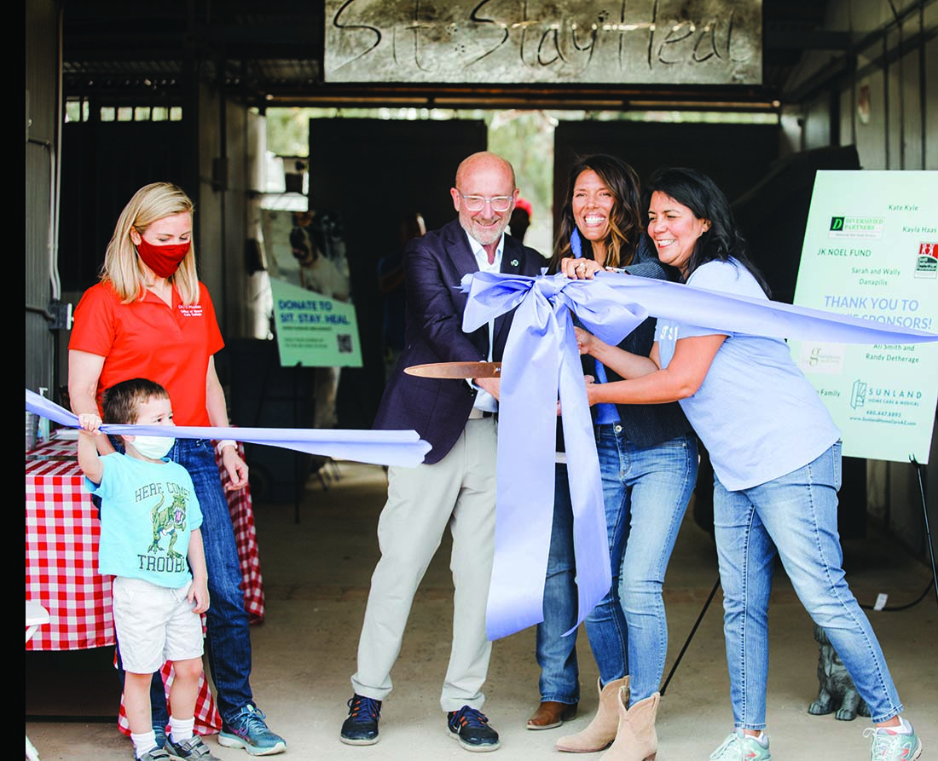

Sit Stay Heal Ribbon Cutting Ceremony
From left to right: City of Phoenix Mayor, Kate Gallego and son, MIDWESTERN UNIVERSITY | Dean of Veterinary Medicine, Dr. Tom Graves, Terra Schaad, City of Phoenix, Council District 4 and Vice Mayor, Laura Pastor
Want to learn more about Hunkapi Farms?
Take a look into what the farm looks like on any given day and how you can help keep Hunkapi in Scottsdale and support their programs. Visit www.hunkapi.org.

“This is a place to open your heart so love can grow.” — Terra Schaad

Publisher’s Note

More Time to Love
This past week, I’ve been quarantined with Covid. Did I love it? Hell no! I wanted to be able to do all the things I usually do—being still is not something that comes easy to me.

While I am grateful my case was mild — it knocked me flat on the mat for the first few days. I realized trying to fight it seemed futile. There was no choice but to ‘let go’ and ‘let it runs its course’. I was forced to practice patience; get rest, more rest, stay hydrated and oh yeah rest! It gave me time to practice love.

This is a temporary twist and turn in life and there will be more to come… because that’s life. For ever changing life. All I needed to do is stop long enough to see the gift here, and practice love.

I’ve had more time to meditate, catch up on Netflix and sleep without the alarm. More time to write and reach out to friends. More time to LOVE my sobriety, my Higher Power, our journey of recovery together.

Stay safe please; this “thing” is not over yet. We need to stay mindful and respectful of each other’s space. Stay in if you’re sick, go back to Zoom 12 step meetings if you must, find a way to stay close to each other with some distance.

We all have a wonderful life ahead. We need each other — and we need each other healthy.

Happy Love Month from Together AZ

Barbara

What’s Love Got To Do With It?
“The greatest love we can have, is the love
we have for ourselves, while making sure we do
what we came here to do, and become
who we came here to become.”

By Dr. Dina Evan

It’s a slippery slope! Where will we end up when what we are being taught to do is choose sides, demean difference and tell the lie that only things of value come in the form of things we can buy.
Today, our role models talk about ethics and then abandon them. Integrity is hard to find in the most important places it’s needed. Humility is nearly non-existent and honesty left several years ago. I never thought I would hear myself use the expression, “In the old days...” but I never expected to get this old in the first place! In today’s jargon, it may be time for an awakening. So, what’s the answer and how do we turn this slide away from important values into bump up in consciousness?? Love may be the only answer, perhaps not the kind in a Valentines card, but then again, love comes in many forms.
The first one is the love we have for ourselves, not in an arrogant or selfish way — but the kind that gives us a stomach ache when we don’t stand in our integrity, as opposed to going along with the abundance of judgment and separation.

Where did we....get the idea that any person has more value than another based upon the color of his or her skin or the language they speaks? We often judge others based upon the amount of money someone has in the bank or their zip code. The greatest love we can have is the love we have for ourselves, while making sure we do what we came here to do, and become who we came here to become.
The second most important kind of love is the kind we have for others, free of judgment and without prejudice. What would the world look like if women and men were treated with the same sense of value and given the same opportunities, or the elderly were as valued as the young, or the person without the ability to get a higher education was offered opportunities as meaningful as those with higher degrees. Spiritual and emotional gifts come from awakened souls and spirits and not always from higher education.
Many of our history makers were never educated in a college. They were educated by life, often lives filled with challenges and pain. Ryan White helped us learn about AIDS and Rosa Parks fought against discrimination. Presidents Harry S. Truman, Abraham Lincoln, and George Washington never attended college but made huge contributions to our democracy. Bill Gates and Steve Jobs never went to college either. It was simply their calling and, in their hearts, and minds, to share their gifts with love for all of us. Love for ourselves and others often comes with the question, “Am I doing what I came here to do?”
In addition, there is love for the earth and how we care for it, love for our laws and how we abide by them, love for our teachers, our parents and kids, love for those who serve or keep us safe or care for us when we are ill. Clearly, it’s time this Valentine’s day to open our hearts and look at all the ways we can demonstrate love for all of humanity, all our families in fact, literally, everyone. Now that may sound Pollyannaish, however, until love is the overriding motivation on this planet we will remain in big trouble.
So this Valentine’s day perhaps we can expand our concepts, give our beloved that special card or gift and then also take a moment to ask ourselves whether we are embodying the love in our own lives and acting from it in all the ways life offers us opportunities to do exactly that.
We have love for each of you and we appreciate the opportunity to share our thoughts with you each month. We love you for your courage, the truths you share in meetings and the support we give each other.
Let’s all open our hearts and make love the guiding priority together, starting now.

Dr. Evan is a marriage, family, child therapist and consciousness counselor. She has presented nationwide seminars and workshops, written several books and created meditation CDs for couples, individual and mental health professionals. She has won national acclaim as a human rights advocate. Visit drdinaevan.com or call 602-571-8228.

“The Knotty Problem with Caretaking in Recovery”
By Ken Wells, MDiv, MA, LPC, CSAT, LSAC

“Somebody loves you if they call you out on your bullshit. They’re not passive, they don’t just let you get away with murder. They know you well enough and care about you enough to ask you to chill out, to bust your balls, to tell you to stop. They aren’t passive observers in your life, they are in the trenches. They have an opinion about your decisions and the things you say and do. They want to be a part of it; they want to be a part of you”. —Ryan O’Connell

uch of my life has been about caretaking. I felt the need to take care of my mother’s feelings, my dad’s fatigue and to please my older brother’s expectations. I became a pastor. I sat with families who lost loved ones. I absorbed the pain of those whose hearts were broken by other tragedies. I worked in large churches as an assistant and focused on caretaking the senior pastor and others. I sought approval through comforting others and rescuing them from their plights. Subconsciously, I hoped that if I cared enough for you, the universe would reward my good deeds and make me happy. It didn’t work. It hurt me and it hurt the ones I tried to care for. The harder I tried to rescue others, the more I felt victimized. I watched my efforts to care for others blow up in my face. I felt disillusioned and overwhelmed. Underneath I was very angry.

Caretaking others is common
It is the act of taking responsibility for other people while neglecting responsibility for ourselves. It is subtle and blinds the insight of the caretaker. They often don’t see the destructive nature of their caretaking. It immobilizes others from developing their own capability of taking responsibility for themselves. Parents caretake their kids with their advice, judgment, money and other forms of control. It always backfires. Caretaking is a curse that debilitates everyone involved. Here are a few considerations to address caretaking:
Face what you fear will happen if you don’t caretake. Ask yourself the question, what are you really afraid will happen if you don’t rescue? Explore not only what happens to your loved one but what do fear will happen to you? Ultimately, you will need to embrace unwanted feelings of angst, anxiety, rejection, abandonment, etc. Sit with your fear. Take responsibility for your own feelings and learn you can survive even thrive — without taking responsibility for someone else’s feelings and responsibilities.

Detach. Clinging to the control that caretaking requires is exhausting and is ineffective. You must let go and allow your loved one to face the consequences for their choices and behavior. They won’t take the path you would choose. The path they choose may be circuitous but eventually will take them where they need to be. They will find their peace in life on their own terms, not yours. So, ease your own pain by letting go and choosing to no longer rescue.

Set boundaries. Create internal boundaries around your obsessional thinking towards caretaking your loved one. You may need to practice a 3-second rule by interrupting your compulsive thoughts to rescue and focus elsewhere. It will take conditioning. You will need to set external boundaries and disengage from the activity and presence of your loved one. Setting up physical boundaries of no or limited contact will be required and is difficult.

Be true to yourself. Separation will help clear the air. You will see more clearly what your personal needs are. The most generous behavior you can choose is to take responsibility for yourself. Taking care of what you feel, want and need can only happen when you separate from caretaking others. It’s a way of being true to yourself. Being true to yourself allows others to take responsibility for themselves.

Frequently, the frenetic activity from family and friends that surrounds an addict is about rescuing and caretaking. The resolution is for the caretaker to stop and embrace their own vulnerability to hurt and personal pain. Only then can the compelling urge to rescue give way to acceptance and personal peace.

For more information on Ken Wells, Psychological Counseling Services or the PCS Intensive Program, please visit website www.pcsintensive.com. 480-947-5739

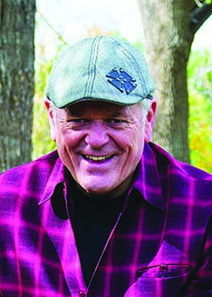Ken Wells’ therapy focus is on Partner Betrayal Trauma, Couples therapy (specialty betrayal trauma), Depression recovery, Cognitive Behavioral, Experiential- Outdoor Therapy, Sex Offender Therapy.

Reason, Will and Emotion

By Coach Cary Bayer

Many moons ago when I was living in Woodstock, NY, my wife and I had hit a bumpy patch and decided to seek some counseling support from Bert Shaw, a wise man who helped many dozens of people put the trains of their lives back on track.
Bert had succeeded in the world and not of it, having risen through creative ranks in the advertising game and then running the Pathwork Center, a spiritual organization about 20 minutes from Woodstock.
One of the things that Bert espoused in his counseling work was the tripartite nature of the human personality broken up into reason, will, and emotion. The idea was that, while every person has each of these qualities active in their lives, one tends to dominate, while the other two are more recessive. Let me give you an example that will help make things clearer, and aid you in discovering which tendency tends to be your most present.
Suppose you have an appointment to play tennis at 9 AM; so three other people are counting on you to show up on time, or else they’d have to wait to get started playing, cutting in on the time that the court is theirs. So you set your alarm for, say, 7:15, giving you an hour and a quarter to wash up, meditate, get dressed, have breakfast and leave for your half-hour drive to the club.
Now suppose you worked out at the gym the night before. Let’s assume for this discussion that you’re driven mostly by emotion. And after the workout you were tired and didn’t feel like taking a shower to clean off all that perspiration then, that you’d put it off for before bedtime. But when bedtime came around you were even more tired and felt even less like showering than you did hours before. So you decide you’ll shower in the morning.
But let’s say you didn’t sleep so well that night, and by the time the alarm rings you feel like you really could use some more time in bed. So you stay under the covers and get out of bed, maybe by 7:30. Now you’re on a shorter time leash to get out by 8:30. So you take that shower, cut your meditation time in half, and quickly run out the door, grabbing a protein bar to eat while driving, instead of sitting down to a nice relaxing breakfast with your partner.

Did you notice that the word ‘feel’ or ‘felt” was used three times in that story?
A writer who chooses his words carefully, I don’t typically repeat a word so often in such a short space, but I deliberately did this time to emphasize that feeling in the moment is what drives the way an Emotion Type behaves.
A Reason Type, on the other hand, would have showered when they got home from the gym, knowing it’s intelligent to shower off sweat right away rather than waiting hours. Such a person might have scheduled the previous day’s workout to even earlier than the Emotion Type did. This person would have been able to get out in the morning easier than the more emotional counterpart.
A Will Type might have even done a gym workout late at night—instead of skipping it entirely—if that person has a commitment to working out on days when they doesn’t play tennis. They would have forced themselves to shower off the workout even if tired and didn’t feel like it. Their will would have driven the action.
It’s not that one type is better than the other; you are who you are and are made up the way you are. But it’s valuable to recognize what drives you, so you can allow the more recessive abilities to show up when useful.
For Emotion Types that means enabling reason and will to exert influences more often.
For those driven by reason, more will and emotion can help create more balance.
Lastly, Will Types can be happier when reason and feelings can express themselves.
Visit www.carybayer.com

Should You Quit Smoking and Drinking at the Same Time?

Studies performed on rats show that smoking and drinking simultaneously can increase neural damage in particular brain regions. Researchers reporting in ACS Chemical Neuroscience found that the combined effects of smoking and drinking, which are harmful individually as well, led to an increase of reactive oxygen species in the brain’s hippocampus compared to the rats given just tobacco and no alcohol.
In short, there’s proof that smoking and drinking together cause increased damage. Studies show heavy drinking is also much more common for smokers than non-smokers. And drinking can negatively impact smoking cessation attempts.
When a person makes lifestyle changes and decides to stop drinking, they might also wonder if quitting smoking at the same time is a good idea. Might as well phase out two vices at once, right? For people considering quitting both smoking and drinking simultaneously, know this: It can be done, and it might actually set you up for greater success.

What the Experts Say
Experts tend to vary on which method—quitting drinking and smoking together or one after the other—is the best. This is largely due to the fact that relapse is a factor to consider, and some believe that quitting both drinking and smoking at the same time might increase the chances of relapse. Psychotherapist William Anderson is a proponent of quitting one and then tackling the other.
He says, “I think trying to go cold turkey on both cigarettes and alcohol at the same time could set you up for a total relapse on both if you had a slip with either. I think it would be good to break one connection first.”
However, Dr. Damaris J. Rohsenow from the Center for Alcohol and Addiction Studies at Brown University has a different outlook. Dr. Rohsenow is a research professor who has conducted clinical trials on drinking and smoking, and on smoking among people with alcohol or drug use disorders for about 25 years.
She says, “It is a good idea to quit smoking and drinking together or soon after each other. There is plenty of evidence that drinking alcohol makes people crave cigarettes more, so it is much harder to quit smoking while continuing to drink. Therefore, quitting drinking may make it easier not to smoke.”
Dr. Rohsenow also notes how studies show there is no harm in quitting both at the same time, and that “evidence shows people with alcohol use disorder who also quit smoking soon afterward had better long-term success with quitting drinking compared to those who continued to smoke.”
Evaluate, assess, and figure out what works best for you.

Simultaneous quitting is tough. Mentally prepare yourself for the possibility that this will be a serious challenge and that you will want to be equipped with the right tools, support, and mindset.

Prepare ahead
Don’t go into such a big lifestyle change blindly. Catherine Costantino, an alcohol and smoking cessation researcher with over 15 years of experience in the field recommends setting a specific “Quit Date” and sticking to it.
“To prepare for a smoking quit,” says Constantino, “get nicotine replacement therapy, like the nicotine patch or nicotine lozenge or gum, or Chantix/Wellbutrin, and use it correctly.”
Certain situations, like parties or sporting events, may be a “high-risk” environment. Arm yourself with self-awareness and avoid those situations in the beginning.
“Make sure your high risk (HR) situations are assessed ahead of time and that you have plans to avoid, and/or alter those HR situations and make sure you have substitutes available like chewing gum, mints, straws, non-alcoholic drinks, favorite treats, fun activities,” advises Constantino.

Get Connected with a Program
Seek out, research, and connect with a community of like-minded people with similar goals to yours. You might find that quitting both means connecting with others who are doing the same or have experience with both. There are online smoking cessation programs, including one from the American Lung Association, which have proven effective for people. Online programs for smoking cessation prove very effective. One study found that “The results [of an online smoking cessation program] provide some initial evidence that delivering such a program is feasible and may reduce the risk of alcohol-involved smoking lapses.”
If you’re looking for support for quitting alcohol as well, a number of online and in-person options exist these days.

Find Additional Support
During your quitting journey, surround yourself with sober friends or sober allies — people who, support you on your sobriety and cessation journeys. Find people with whom you can speak with honesty and share your journey along the way. Loving and supportive friends will want the best for you, even if that means it’s a different “you” showing up at their birthday.
And, if your usual pals are heavy drinkers and smokers, you may need to take a step back from those friends to set yourself up for sobriety success. You can fill any temporary (or permanent) social gaps by making friends with other people who have successfully quit smoking and drinking. Align with people who have the same goals as you do and have reached them; then, watch yourself soar, too.
You can also find support in formalized settings, like clinical counseling sessions. Getting connected with a mental health professional like a psychologist, substance abuse social worker, or therapy specialist is a great way to set yourself up for success and have a safe, nonjudgmental space in which to process your emotions.

Prepare, and Plan to Succeed
It’s essential to mentally prepare yourself for the process you’re about to embark on and set yourself up for success.
Dr. Christopher Kahler, Chair of the Department of Behavioral and Social Sciences at Brown University School of Public Health, says, “We know that people who drink and try to quit smoking are about four times more likely to pick up a cigarette on a day they are drinking compared to a non-drinking day.” This means that quitting both at once can work in your favor.
Dr. Kahler found that the risk of smoking is eight times higher if a person drinks heavily. “I recommend that drinkers trying to quit smoking avoid alcohol for at least two–ideally 4 four–weeks after starting their quit-smoking attempt.”

Embrace Mindfulness Practices and Positive Psychology
The benefits of meditation are widely documented and seemingly endless. While you’re stepping into the sobriety arena, consider adding meditation to your toolkit. It will help increase your mindfulness and provide a more stable and strong foundation for your sobriety.
Developing calming techniques and self-soothing practices and rituals, like morning meditation and a hot shower before bed, can help deter a potential stress-induced relapse. Apps like Headspace, Calm, and 10% Happier are great for a beginning meditator.
Above all, be kind to yourself in the process of quitting – whether you’re quitting alcohol and smoking at the same time or individually. This is challenging work that takes time; be kind and loving towards yourself in the process.
(source: tempest.com)

Understanding an Addicts’ Mind
From Scottsdale Recovery Center Blog
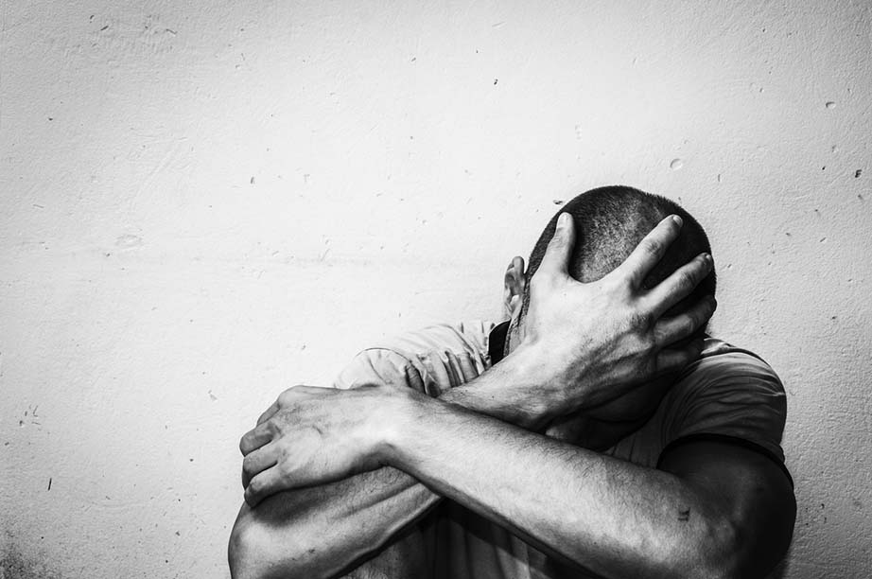

For people struggling with addiction, it’s hard to see what is wrong with their behavior until it’s too late. For people looking from the outside, it’s hard for them to understand why an addict does not see what they’re doing is wrong. Unfortunately, this is often the case with people outside of addiction. There is a massive stigma around addiction and a severe lack of education on the subject. Most people know the basics, people can get addicted to drugs or alcohol if they consume too much often enough. However, there is so much more to this most people have only grazed the surface when it comes to knowledge on this subject. In this article, we are going to help you better understand what goes on in addicts’ minds and why they continue to live in addiction.

What is Addiction?
First, let’s define what addiction is. Addiction is defined as “the fact or condition of being addicted to a particular substance, thing, or activity.” What people tend to think is this kind of behavior is a choice. Though the initial first decision to use a substance is a choice, what happens afterward is not entirely up to the user. What happens when someone actively uses a substance is their brain chemistry gets rewired. They start becoming a different person. You may know some people in your life that seemed like upstanding/wholesome individuals, but they somehow fell into addiction. Alcohol use, drug use, gambling, sex addiction, overeating, etc. are all common addictions people deal with. How do people get addicted to these kinds of behaviors?

How Addiction Works
Essentially, substances or behaviors manipulate a person’s brain into thinking they absolutely need drugs, alcohol, or whatever in order to feel normal. They manipulate the amount of dopamine released in the brain, which is the hormone that is released through rewarding behavior. When this hormone is released in the brain, a person feels happy, uplifted, and excited. If substances and behaviors are abused often enough, the brain will release less dopamine which results in people craving greater amounts to get the desired effect.
This is how addiction forms; the brain tells a user they need drugs/alcohol/gambling/sex/food more often in order to feel happier. Addicts may know what they’re doing is wrong, but are unable to stop. Think about it this way, you decide you need to start working out after work so you tell yourself “today is the day”. Once you get off work, you realize how tired you are and your body convinces you that you need a rest. Next thing you know, you’re on the couch binge-watching Netflix. You want to get in shape and be more active, but your body/mind has manipulated you into being comfortable with relaxing on the couch. The kind of thinking goes for addicts. They may want to change or at least see what they’re doing is self-destructive, but their mind/body has told them they can seek comfort in substances.

What Addiction Does To A Person
Addiction can cause a person to turn into a completely different person.
They May Become Liars: Addiction can do a lot of things and one of the most common behavioral traits is it can create is lying and manipulating. Long-term substance use can cause a person to become someone they aren’t. Oftentimes, those who struggle with addiction start to lie to friends, family and loved ones just to save face.
They Become More Selfish/Manipulative: Another trait is selfishness/manipulation. Keep in mind, it is not the addict who is selfish, but rather the addiction causing them to act selfishly. One thing we often see addicts doing is stealing money from loved ones to fund their habits. They may do this in secret or try to emotionally manipulate a person into giving them money to “help out”. Addicts will often find someone that has a soft heart or someone who can be easily manipulated into doing what they want them to do.
Their Lives Are Centered Around Substances: Addiction is powerful and it can have serious side-effects. Another way it affects a person is by causing them to center all their life plans/decisions on getting a fix. Any time they commit to something, they may try and make sure there is some kind of substance present to give them a feeling of euphoria or numbness. If they do attend events, they may come inebriated and under the influence. If they realize they are unable to have some kind of chemical refuge, they may just stay home and shut everything out. It may even get to the point where they have a hard time discerning right from wrong. Many addicts start to live dangerously when they are deep in addiction. They start to develop a “nothing to lose” mentality, which can result in criminal behavior and endangering themselves or others.
Addiction is a serious disease and it can completely change a person. Maybe you know someone in your life who is struggling with addiction. It may seem hopeless, but don’t give up on them. Think about what we’ve discussed today; addiction is the problem, not the person. Just remember that people struggling with addiction may be acting selfish, but this is not their authentic self. Addiction has shaped them into something that they are not.

Talk to Someone Who’s Been There. Talk to Someone Who Can Help. Scottsdale Recovery Center holds the highest accreditation (Joint Commission) and is Arizona’s premier rehab facility since 2007. Call 866-893-1276.

